<https://www.knime.com/downloads/download-knime>

<https://seleniumnodes.com/>

<https://www.timeanddate.com/holidays/sweden/2001>

1. Download and install KNIME Analytic Platform, and install all possible node repositories
2. Covering general information:
   1. KNIME works through passing blocks of data from one function to another, each node provides a function. These are show in black lines and black triangle ports
   2. The sequence of nodes creates a workflow
   3. The workflow can be controlled through flow variables. These are expressed through red dots and red lines
   4. As you work, collect related knime nodes into wrapped metanodes. Metanodes can be nested, allowing you to make sure that everything needed at any level can be seen in one screen
   5. The scope of flow variables can be isolated by putting them into wrapped metanodes. Be careful to ensure any necessary input and output flow variables from a metanode are properly exposed.
   6. Provide a description for each wrapped node to give its function, input, and output.
   7. 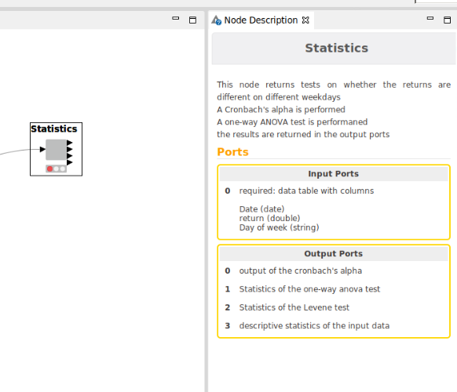
   8. Annotate with simple labels the function each node is playing for the particular workflow, eg: 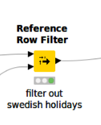
   9. Use any help you need, including documentation, posting on forums, asking colleague to help, short of asking someone to do it for you. Please document what you asked and what help you got.
3. Get performance series
   1. The data file is a json file of a performance series. Use a json reader node to read it.
   2. Use the json Path node to capture the time and the level into separate lists. The time is returned as number of milliseconds since epoch.
   3. Use an ungroup node to convert the lists into a data table.
   4. Use a java snippet node and write a java line to convert the time from milliseconds since epoch to a date
   5. Use the time transformation nodes to help you to remove weekends from the series
   6. Remove weekends
4. Get Swedish holidays
   1. Download and install a trial version of the selenium nodes
   2. Parse and obtain the Swedish holiday dates from 2004 to 2019

Suggestion:

* + 1. Use a Table creator node to create a table of years from 2004 to 2019
    2. Use a table row to variable loop node to start a loop over the years
    3. Modify the year in the timeanddateurl (see above) for Swedish holidays above, using a java edit variable node, return as a flow variable
    4. Use a WebDriver Factor to pick a browser
    5. Use a Start WebDriver and set the url using the flow variables and the flow variable from your loop
    6. Use a Find Element

1. Daily returns
   1. Remove Swedish holidays from the performance data
   2. Compute a daily return series (between the remaining dates) from the performance series
2. Statistics tests
   1. Test with one-way ANOVA if the returns are same or different on different weekdays
   2. Pivot the return series to a table with weekdays as the columns and the return in rows
   3. Use a column loop to remove any gaps in the returns in each weekday column and truncate to the largest table with filled data
   4. Do a Cronbach’s alpha test
3. Export your workflow and make it available to me

**Questions**

Q. What is the average daily return? **Average daily log return: 1.812E-4**

**Only used the KNIME documentation and google search. I did not post/ask any questions.**

Q. why is the total performance return not equal to the number of data points times the average daily return?

**Cumulative performance is a path dependent; therefore extrapolating from daily average will give different/incorrect value.**

Q. From the ANOVA test, is there any seasonality by weekdays?

**Obtained a p-value of 0.072 which is slightly above the significant level of 0.05 (95% confidence interval). Since the p-value achieved is very close to the threshold we cannot outright come to the conclusion of no seasonality. We also checked the mean and standard deviation of returns grouped by weekdays which did not show significant difference. Similar findings shown in the following paper -** [**THE IMPACT OF DAILY TRADE VOLUME ON THE DAY-OF-THE-WEEK EFFECT IN EMERGING STOCK MARKETS**](https://pdfs.semanticscholar.org/d32c/66eaadc7b6a111ba75cac01c386561b0c6ae.pdf)

Q. Explain the Cronbach’s alpha, is it appropriate to use here?

**Cronbach’s alpha is a method for checking reliability of a test given a set of independent variables. It is most commonly used when one requires assessing the reliability of a questionnaire that is made up of multiple likert-type scale and items. Therefore, this test is not appropriate to use in our case.**

**Examples of workflows**